**Batch Name : SAP ABAP HANA** **DAY-11 ASSIGNMENT**

**EMPLOYEE ID – 46255492** **DATE : 17th OCTOBER, 2022**

**Exercise 1 – Creation of Smartform:**

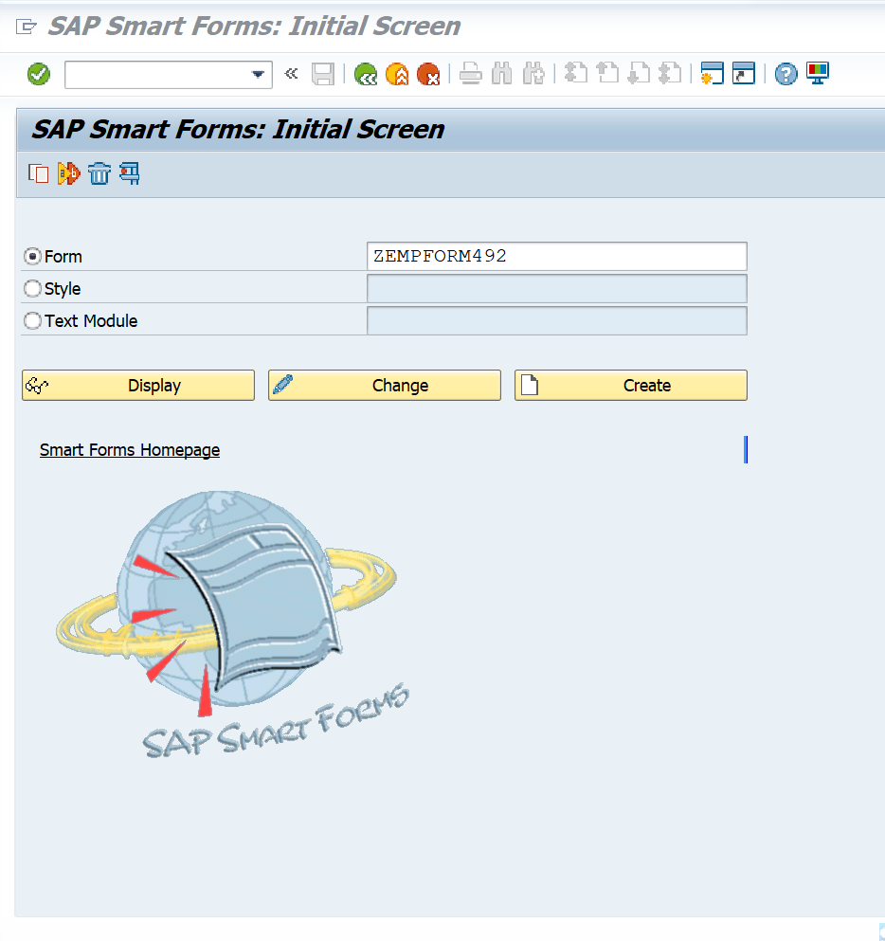

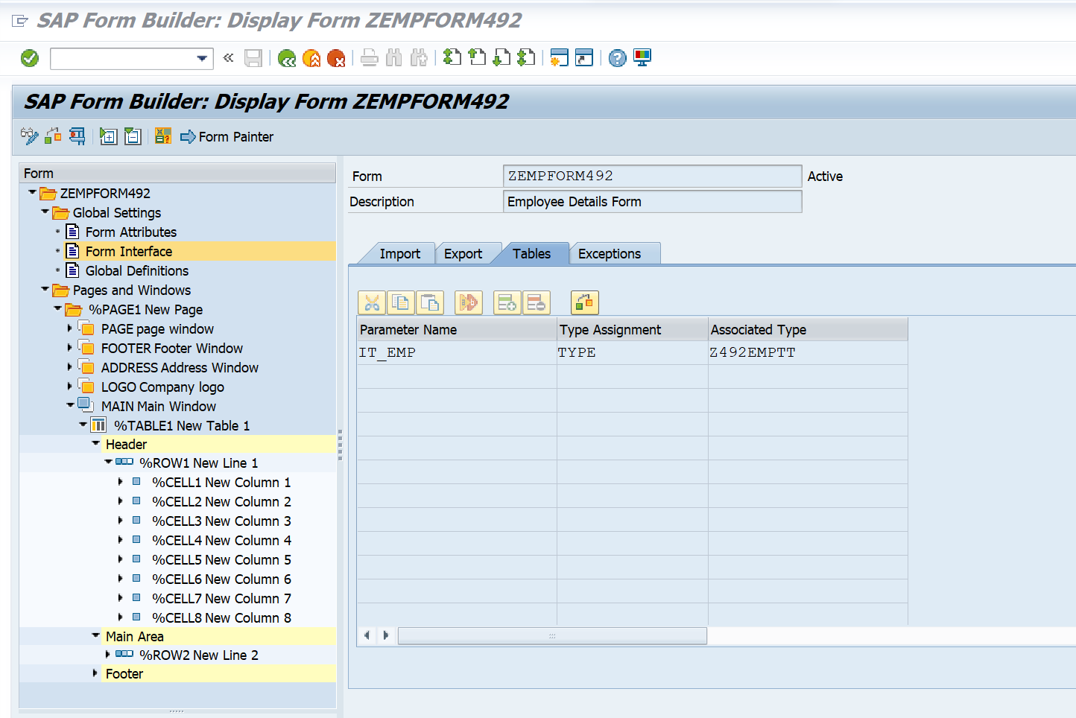

**Exercise 2 – Creation of Smart Style:**

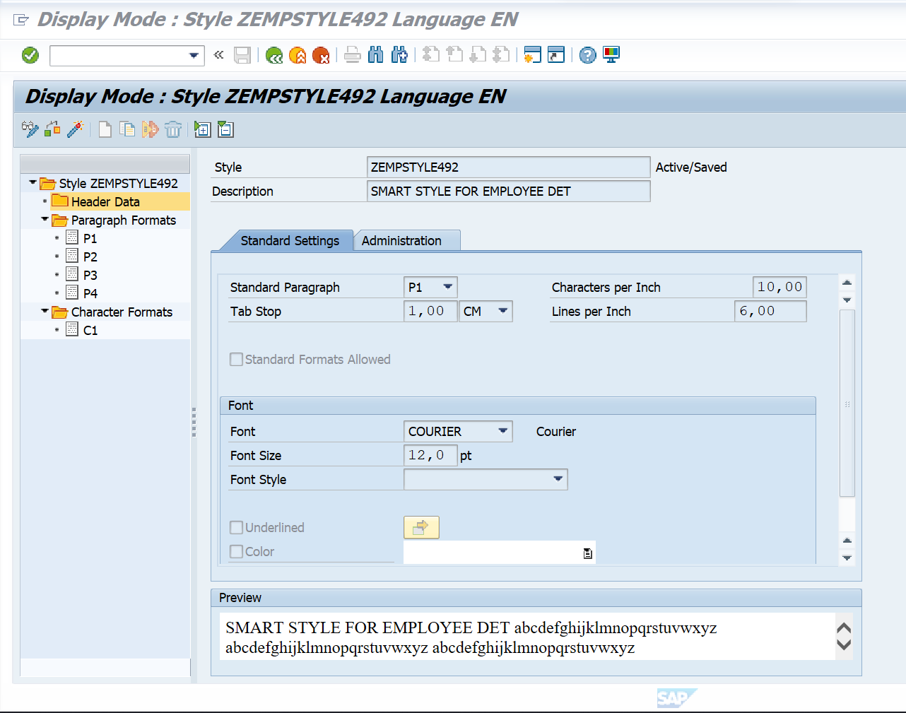

**Exercise 3 – Calling Smartform from the ABAP driver program:**

*&---------------------------------------------------------------------*  
* Modification log:                                                    *  
* -------------------------------------------------------------------- *  
* Date        User name      ID       Change Request   Case ref.       *  
*             Description                                              *  
*&---------------------------------------------------------------------*  
REPORT Z492EMPSF.  
  
DATA: fm_name TYPE rs38l_fnam,  
     IT_EMP TYPE Z492EMPTT,  
     WA_EMP TYPE ZEMPSTR.  
  
SELECT EMPID  
EMPFNAME  
EMPLNAME  
DOJ  
DEPTID  
DEPTNAME  
HOD  
SALARY FROM Z492EMP INTO TABLE IT_EMP.  
  
  call function '/1BCDWB/SF00000762'  
*   EXPORTING  
*     ARCHIVE_INDEX              =  
*     ARCHIVE_INDEX_TAB          =  
*     ARCHIVE_PARAMETERS         =  
*     CONTROL_PARAMETERS         =  
*     MAIL_APPL_OBJ              =  
*     MAIL_RECIPIENT             =  
*     MAIL_SENDER                =  
*     OUTPUT_OPTIONS             =  
*     USER_SETTINGS              = 'X'  
*   IMPORTING  
*     DOCUMENT_OUTPUT_INFO       =  
*     JOB_OUTPUT_INFO            =  
*     JOB_OUTPUT_OPTIONS         =  
    tables  
      it_emp                     = IT_EMP  
*   EXCEPTIONS  
*     FORMATTING_ERROR           = 1  
*     INTERNAL_ERROR             = 2  
*     SEND_ERROR                 = 3  
*     USER_CANCELED              = 4  
*     OTHERS                     = 5  
            .  
  if sy-subrc <> 0.  
* Implement suitable error handling here  
  endif.

**OUTPUT:**

